PROJECT PROPOSAL



**INVENTORY MANAGEMENT SYSTEM**



July 4, 2018

Scott Ritchie – 991442125

Doan, Ngoc Phuong Thao – 991466176

Sheridan College

**TABLE OF CONTENTS**

* Project title 0
* Description of the project 2
* File description 2
* Screen designs 3
* UML diagram of class relationships 4
* Description of any introductory research 5

I – PPROJECT DESCRIPTION

Inventory management systems track items through a business operates in, it helps to keep their business running smoothly and profitably

The kind of data we will be keeping track of are the item ID number, the item name, the item price, the quantity of the item and a description of the product.

The intended user of this application would be for a store, or a warehouse with multiple items in their stock.

This application would be useful for any place that needs to keep inventory because its makes it easier for them to see how much of the product they have on hand, when they need to replenish their stock and the ability to look up and alter the price of products.

The main features of this application are the ability to add and remove items, change the prices and to be notified when you are running low on stock and need to replenish your stock levels.

This application helps stores keep their businesses running smoothly and profitably. Regardless of the complexity of number of items they are distributing, inventory management systems will be a valuable addition to your software infrastructure, and one of the fastest way to meet your employees’ and customers’ expectations.

II – FILE DESCRIPTION

|  |  |  |
| --- | --- | --- |
| myProduct.txt | | |
| **Field Name** | **Data Type** | **Description** |
| productID | int | uniquely identifies the item (primary key) |
| name | String | the name of the item |
| price | double | the price of the item |
| quantity | int | keeps track of the quantity of the item |
| description | String | a brief description of the item |

III – SCREEN DESIGN

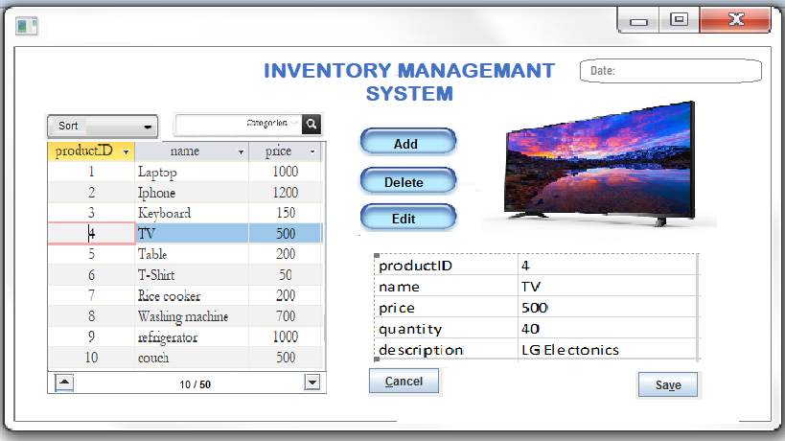

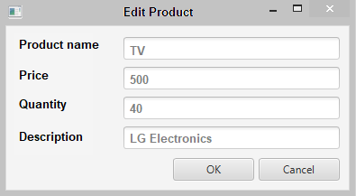

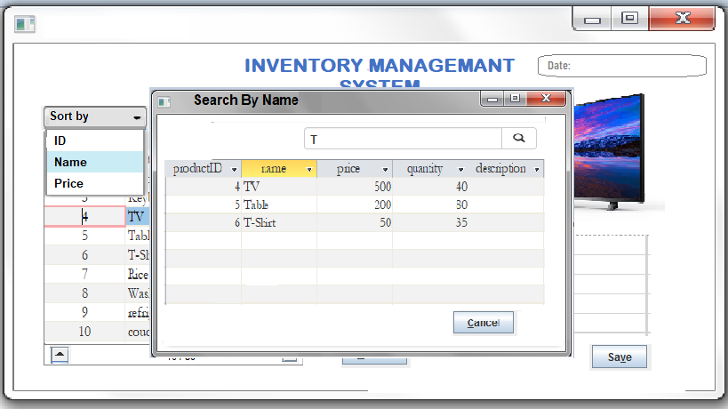

IV – UML diagram

ProductList

* productList: ArrayList<Product>
* ProductList()
* ProductList(Product…)
* ProductList(File)
* set(int, Product): void
* get(int): Product
* add(File): void
* add(Product): void
* contains(String): Boolean
* indexOf(Product): int
* isEmpty(): boolean
* delete(Product): void
* sort(): void
* loadFromFile(File)
* writeToFile(File)
* searchByName() ProductList
* searchByID() ProductList
* sortByID() ProductList
* sortByName()
* sortByPrice()

+ toString(): String

Product

* productID: int
* name: String
* price: double
* quantity: int
* description: String

+ Product()

+ Product(int, String, double, int, String)

+ setProductID(int) void

+ setName(String) void

+ setPrice(double) void

+ setQuantity(int) void

+ setDescription(String) void

+ getProductID(): int

+ getName(): String

+ getPrice(): double

+ getQuantity: int

+ getDescription: String

+ compareTo(Product): int

+ toString(): String

Main

productList: ProductList

even handers …

V – RESEARCH DESCRIPTION

The type of research we may need to do to help assist us with the development of our program would be to research programs similar to the one we are creating, I.E an inventory maintenance program, we may also need to research more info on GUI to help us complete this project, such as adding events

Modifications

The modification’s we have made to the program are, the ability for the user to login so not anyone can access the program and alter the inventory.

We have also made changes to the GUI appearances of the windows as well as added more windows, such as a new pop-up window to edit items and to show detailed information in the inventory.

We also added a search window with two options, search by id and search by name instead of two windows “search by name” window and “search by id” window.